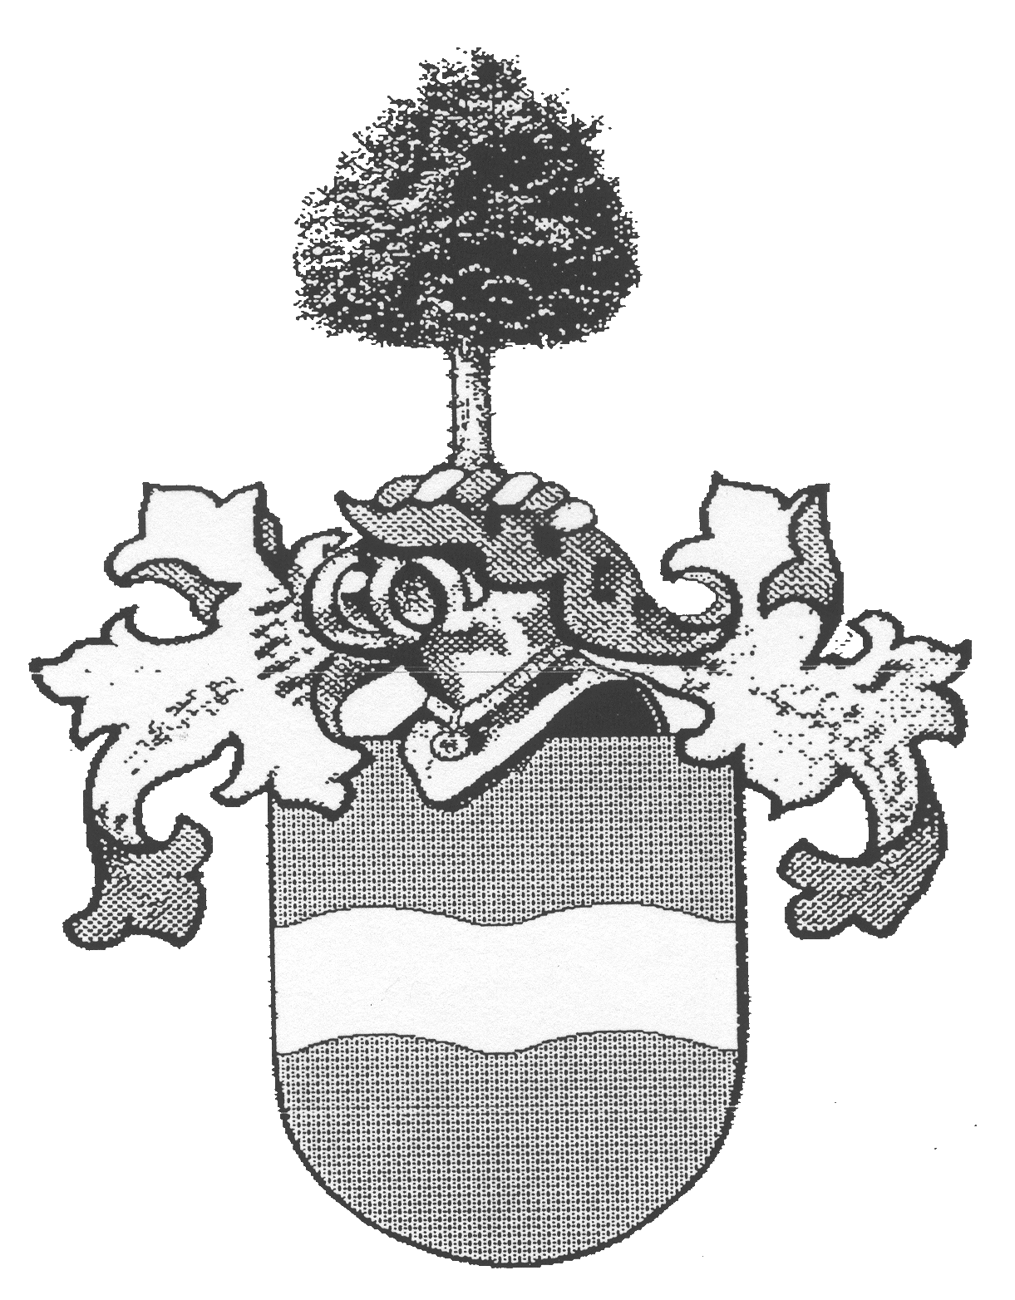

Von RUNNE

Is the original form of today’s family name

Von RÖNN, Von RÖNNE, or Von RÖNNEN

Von RUNNE

Is the original form of today’s family name

Von RÖNN/E/N

The identification of the knight “van deme Runne”
with the Ostinger family von Rönne ensued on the basis of
an investigative transcript by the Chronicler Mushard/v.d. Decken
where entirely unequivocally the name form “van deme Runne”
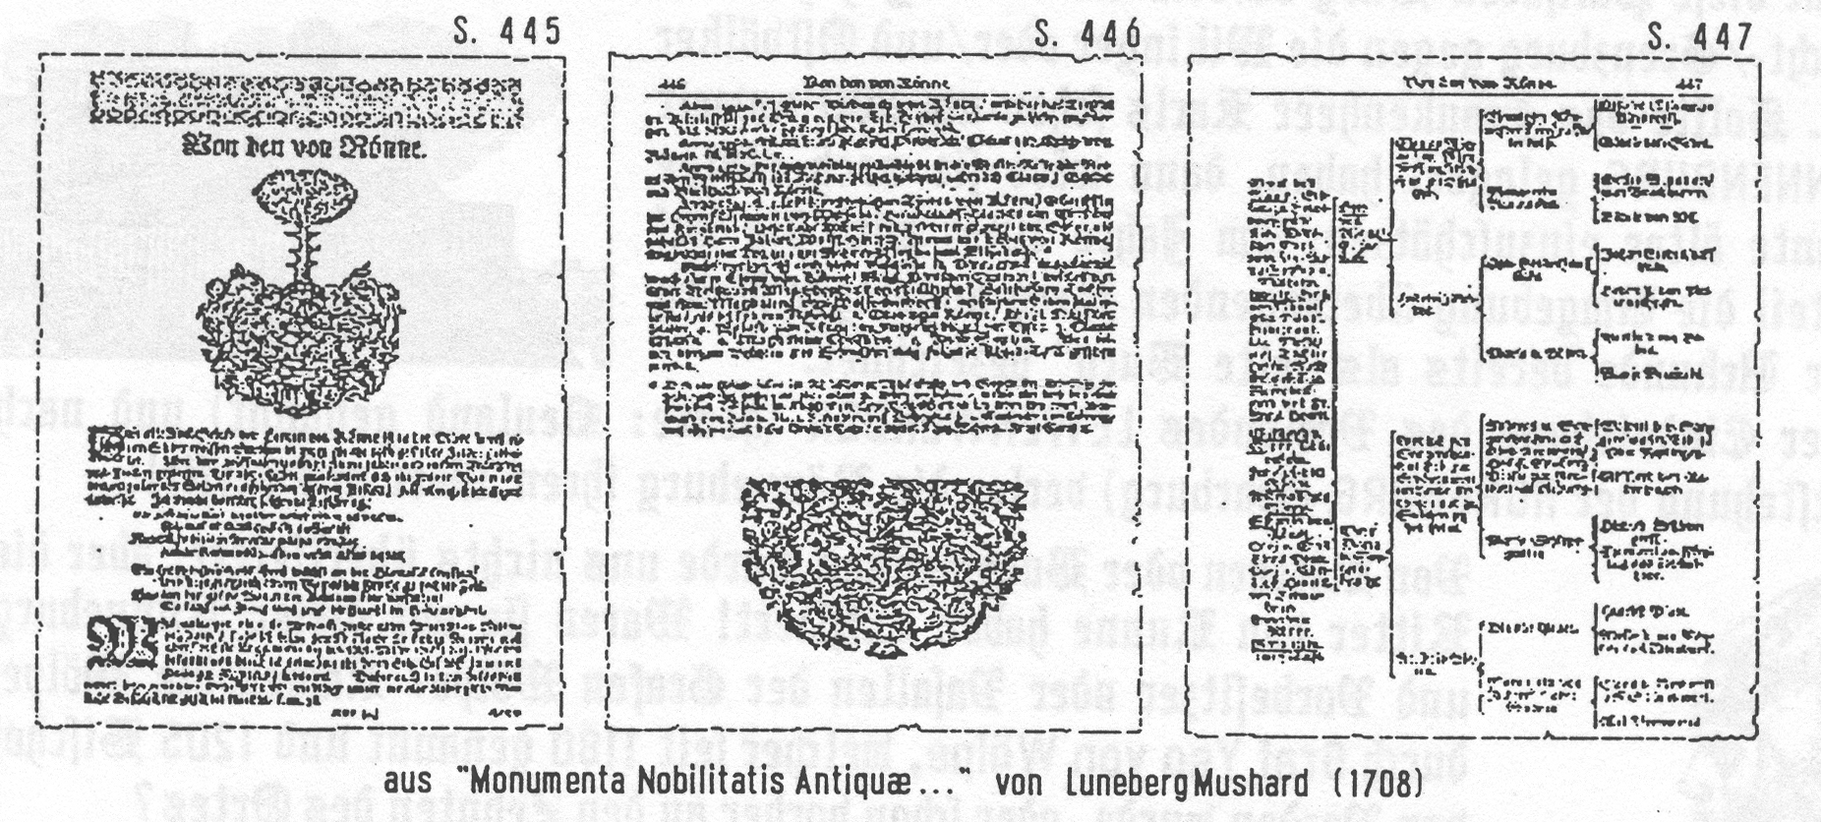
1450 for the family was used. (Knight Archives Stade)

From “Monumenta Nobilitatus Antiquity…”by Luneberg-Mushard (1708)

Not always has the evolution of all the family branches taken place the same way. Also today there are yet single Runne namebearers.

“van deme Runne”

“the von der Rönne?”

Where do we begin the search after our ancestors?

A “very old noble knight” should indeed have lived in a castle. However, here we fall immediately into a great abyss of a lack of knowledge. Were our great-grandfathers now Saxons, or Franks, or even Hollanders? The latter, totally not. But what do we really know?

We know that on November 25, 1242, the Bishop Luder von Verden transferred to the clouister Walsrode the “Oversight” of the Tenth (tithe) at Rennebergh, which the Walsroder Probst Sigfried, of the Counts of Wolpe, had purchased. This “Tenth-declaration” referred to the next door neighbor of the place “aft the castle”. Already around 1233, had the Duchess Kunigunde and her son, Count Konrad von Wolpe, pledged this “Tenth” to the Walsroder. This castle, today named “Rönneberg”, laid on the north border of the bishopric Verden above the Elbe lowlands, where today the southern border of Hamburg by Meckelfeld passes.

Is this Rönneburg a family (genealogical) castle?

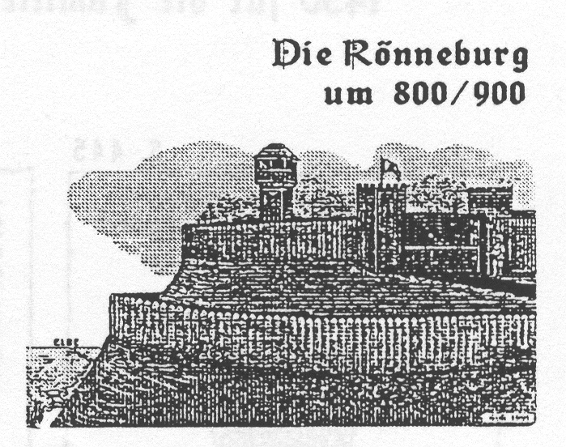
Had here a great-grandfather lived? According to newer findings, this palisade castle had served, in the 9th and 10th Centuries as a refuge (border fortress against the Vikings and east people. Should the Franken army of Charlemagne around 800 A. D. have besieged around Runneburg; then it should be estimated a few decades older. In the year 1004, it was, on a part of the surrounding outstanding mountain, laid out as a castle in a document; already “old castle” designated. After the Dukedom of Vorlande LEWENWERDER (today is named Neuland) and according to the origin of Horeburg (Hamburg), the Rönneberg lost her worth and decayed.


From the knights or the villagers was nothing left over for us. But the Knight von Runne has existed!!! Were they previous owners of this Runneburg or descendants of Count Wolpe? Did the Wolpes come through Count Yso von Wolpe, who was since 1180 named, and before 1205 became bishop of Verden, or already before this to the decades of the place? This could not be answered until now!

The matter of fact is, that it, in the nearness of Wolperburg” by Erichshagen (Weser), earlier a place “Runne” west of the Weser on the ground of today’s suburb of Nienburg was given over, around 1300, into the ownership of the Lords of Tiesenhausen.

Outside it, flowed a Rönne, respectively Runne, today now named “Kulenhamper Beeke”! Round about Vilfen/Asendorf, there was before 800 sundry “Refugees”, under which a “Museborg”, to where the inhabitants from enemy assaults fled. In this wider territory, we find documented, also around 1300, the first Knight von Runne.

What do the documents say to us yet today?

- Count Konrad von Wolpe, in 1250, renounced his rights and estate west of the Weser!
- On January 10, 1252, Count Konrad von Wolpe gave back oversight and estate to the bishop of Minden.
- The counts Gotschalk and Hermann von Purmont sold to Count Heinrich von Hoya, with the approval of the lending lords, of the bishops of Minden, the title in Balge and in “Renne”, also the oversight Natenstadt (in the office Ehrenburg). (Halemunt, 1258)

1300 / “Runne” in the parish Lohe, Office Nienburg (Hoyer UB, I,IV S.36 L.1)
1380 / “Runne” in the “Vogedic Leuenaw” (Hoyer UB, I. V S.30 L.25)

The “von Runne”, however, around the year 1300 was in the ownership of the house of Godestorf, which belonged, before this, to the Castellanus of Thedinghausen Heinrich Klencke (Klenock).

Thereupon, after 1250, yet further, the counts of Hoya acquired, yet further, ownership and land association. In the register of the lending estate of Counts of Hoya, appeared also the knight “Klenock” and the knight “von Runne”. From this register, a few lines:

“DIS IS DAT REYSTER DES LENGUDES DES GREUEN TO HOYEN”

Vere: Her Rodolf Ryddere gheheten clencok

Viue: Dyderik gheheten clencok Ryddere
Elvene: Her Dyderik Rydder und Rodoff knape gheheten clencok
Achte unde vertich: Dyderik, Ortgis unde Rodolf brodere gheheten clencok
Seuen unde ssestich: Her Dyderik von Runne Ryddere und Rodolf sin broder
Ver unde neghetich: Her Dyderik von Runne Ryddere
Sesse und Sestich unde twe hundert: Dyderik von Runne

This name likeness is assuredly no accident, and, one must accept that these brothers Dyderik and Rodolf, with the extraordinary annotation “gheteten clencok” are those which are later named Brothers von Runne, since the “gheteten clencok” appears no more.

Perhaps it is, for the loss of the owners Runne through the death of their father, Heinrich Clencok came and took over the rearing of the children Diederich, Ortgis and Rodolf. Then Heinrich Clencok’s son Kuno died. Then came the Runnes, as they themselves assigned to him the “Tenth” of Gödestorf. Indeed, this or another, as regards relative connection of the widow von Runne with the family Clencok, did not permit itself to be manifested.

Certainly, it is that with the conveyance of the counts of Wolpe and of the loss of the Runne residence, the Hoya and the Counts Aldenburg”Bruckhausen became the new vested owners.

See also “THIS AND THAT/YEAR 1257”!
The “Hoyer Document Book”, wherein old documents are filed, analogously indicates the same named in the Hoyer Owner’s Register, that around 1300

“Lord Dyderik von Runne Ryddere and Rodolf are brothers”

now are vassals of Count Hoya; and Count Wolpe renounced his western areas. Knight Dietrich von Runne and his brother Rodolf were endowed with Godestorf. A son (Filius Wilkini), after that had the “Tenth” at Gödestorf and lived there also.

Another son, named Rudoph, in 1326, was a youthful knight of Count Otto von Bruckhausen, and, in 1336, stood at the top of the castlemen at “Brok at Huchting”, must have lived in this enigmatic castle. In the year 1170, this Brok at Huchting belonged still to Friedrich von Machtenstedt, and, in 1355, will a small village Brucktinghe, with one belonging “Worth?”, be chosen. This Knight Rudolph, also, had used the “Three Dove Seat”.

In the year 1423, south of Bremen, were Hinrik and Robert von Runne (“Pages Bremish Stichts”). The “Robert van Runne page” renounced over to a Klaus Hude, with son and grandson, the “Tenth” to “Wostenbutle”—In the same year, lived his brothers Eler, Williken and Hermann von Runne, who are not further noted by the chronicler.

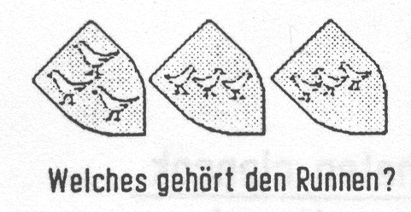
The Runne knights, in the Weser marshes, bore a coat of arms sealed with three birds (doves); the same sealed by the Lord’s of Duvenworth at Hiddigwarden. In a document of 1187 (KL. Pauli Bremen State Archives) hangs five dove seals in three separate executions (legal registrations), as the signed representations indicate.
The Counts of Aldenburg and Bruchhausen died out toward the end of the 14th Century and their landed estates fell, according to agreement, to the brothers Hoya.

At the same time as Knight Rudolph, a castleman at Brokhucting, lived, at a far distance, in Livland (Lithuania) which was conquered by a German ecclesiastical order in the year 1336, is a Johann von Rennen, a ecclesiastical lord at Dorpat, who belonged, without question, to the archjurisdictional successors.
A Cunrad van deme Runne and his son Hinrik occupied in Oederquart (land Kehdinger). Hinrik, in the year 1372 sold this to several Stade inhabitants.

A Vrederike Runneke (Friederich von Runne) occupied, around 1375, and earlier, an estate in Wechtern by Freiburg on the lower side of the Elbe in the land Kehdinger.

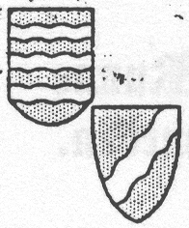
Year 1402, were, by a written agreement (oath of truce) of a Kurd von Runne in Mecklenburg, the wholly oldest Rönne seal; namely the signets of Nikolaus and Johann von Rönne described. Were these the sons of Kurd?
Johann’s seal had three undulating beams drawn across. Nicolaus, however, left entirely the original coat of arms; i. e. only undulated, nevertheless slanting, beams on the shield. After which, they came out of the Ostdinger-Kehdinger realm!?!

Whose vassals

were the “Knights von Rönne”?
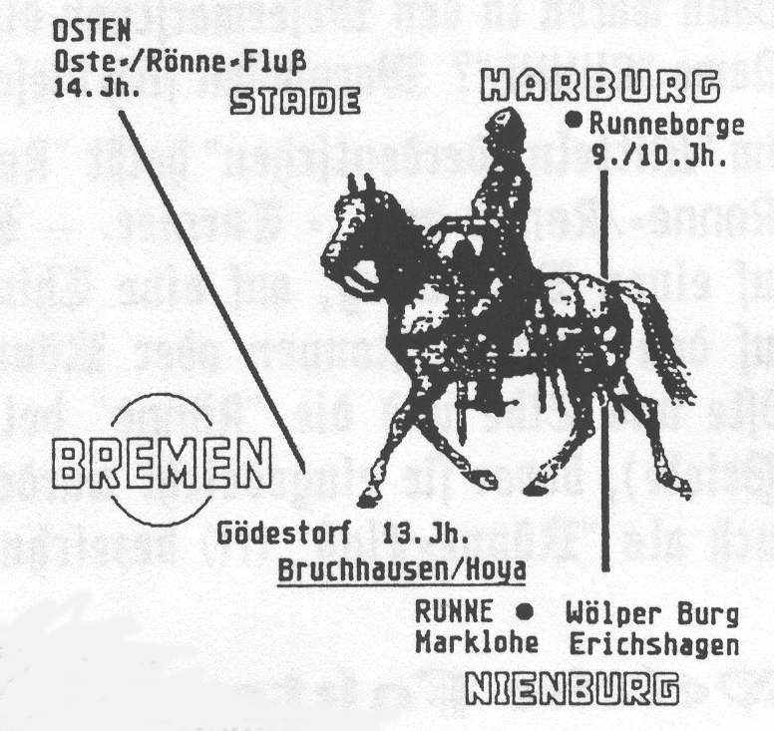
Here, following, is extracted for consideration!!
1. The Counts of Wolpe were their masters because, until 1233, the “Tenth” of the “placed aft the castle” (Rönneburg belonged to the Wolpes. In the year 1205, the bishop of Verden installed Yso von Wolpe the bishop of Verden, and, because, there was also a place “Runne” west of the Weser in the vicinity of the Wolper castle at Erichshagen by Nienburg.

2. The Counts of Aldenburg and Bruchhausen! In the year 1257, went to the county Wolpe, through the marriage between Count Ludolf von Aldenburg and the Countess Hedwig von Wolpe, after her death, to the County Aldenburg. From here, a part again, around 1301, to the Counts von Hoya. The other part, a feudal tenure of the Bremen bishops, remained in the ownership of Aldenburger counts, from where Otto, which he himself now named Bruchhausen or Oldenberg, between 1321 and 1360. It was often too difficult to distinguish. This is also undoubtedly the feudal master Rudolf von Runne out of Götestorf.

3. The Counts of Hoya! After Otto von Bruchhausen’s and his wife’s deaths, the now named feudal tenure, by agreement in 1368, fell to the Counts Gerhard and Johann von Hoya. In the year 1450, the Hoya Count Gerhard, now Bremen’s Archbishop Gerhard III.., vested his descendant Diederich von Runne with the jurisdiction in the parish at Osten.

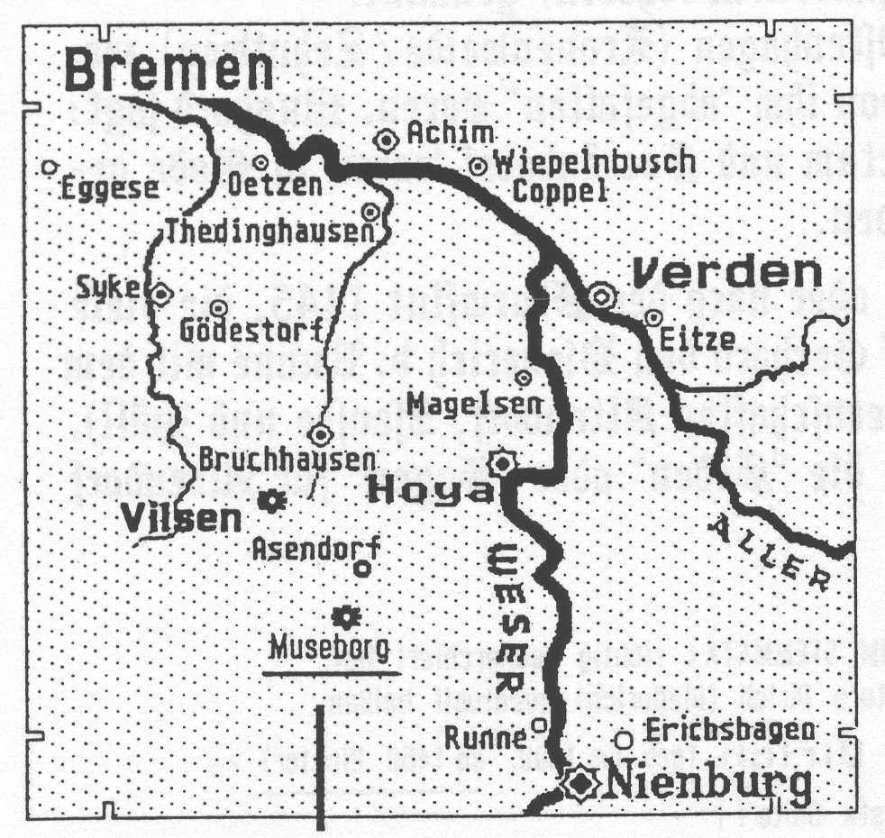
However, also is a thesis of Bruchhausen-Vilsener Archives caretaker H. Bornbusch well possible! This one calls attention that the Duke Widukind’s people before 800 A. D. had placed defenses by Hoya there. There, it is said, the Kulenkamper Beeke once is a Rönne or Runne, whereto a “Mauseburg” (middle upper Museborg) laid. It laid by Asendorf and belonged with other castles of refuge as Muggenburg, Wehrenberg, Wrissenberg, Falkenberg, Vorberg, to a traveler’s safe haven round about Vilsen.

A grandchild of Widukind gave his castle the name Alstenburg (Aldenbur), which then later descendants took up.
It is also entirely possible that the grandfathers of the Knight von Runne, were during the Saxon Wars of Charlemagne before 800, among the warriors of Duke Widukind to be found.

Then were they in the Weser marshes to seek the great grandfathers of the family. Indeed, from where comes the name “Runne”? Why had this name changed so often dialectical?

In the “middle lower German” is said “Renne” or “Runne”; also border (Runneburg=Grenzberg), “Rönne=Renne=spil”=tournament. The place Rönneberg, southerly from Hannover, rested at a Runenberg, on runeplates for old script writings. Later one named Rinnen , on Runenplates on a stable at the fields of Ronnen or Rönnen, wherein “the water flowed to and fro”. The “Rönne between the Oste and Elbe and the “Rönne” by Winsen/Luhe, however, were somewhat broad water courses (tidal inlets) before they were diked. The “Rönne” by Osten was, on an old map, also as “Rönne Stream” (!!) indicated and flowed through Rönne land associations.,

Which facts are we to take into account?

Before 800, there was a “Runne” stream in Widukind’s Weser River marshes. Verden became, in 786, an archbishopric and the “Runne” men were subject to military service for the bishops in Bremen-Verden. The bishopric Verden bordered in the north on the Elbe. By an over the Elbe crossing a border fortress was erected, name “Rönne Castle”, which in 1004, was documented as an “old castle”, and, later, because of the new powerful Horeburg (Harburg) was abandoned to decay. The “Tenth” from the place Rönneburg went, from 1233 until 1242, to the cloister Walsrode.

Before 1300, was the name “von Runne” already in the Weser marshes. Which, there in the feudal register of the Counts Hoya, were mentioned brothers Dyderik, Ortgis and Rodolf, first titled Clencoc, later “von Runne” Knight and Lords at Godestorf.

In 1219, the Bremen cathedral deans already owned a manor and extensive “Tenth” investments in the area Osten (by the Osten, since 1255, also all rights for Hüll and Grossenwörden. In 1372, were the first settlers, named Runne, in Oederquart and Mechtern).

In winter 1396, Archbishop Otto destroyed the castle Ostenhagen (Kranenweide-Zehnten), because the knights, “Tenthowners” at Isensee, had abandoned him. Mushard says: “They are decayed”; i.e. died out. Robbers on horses and sea robbers (pirates) had come into fashion; larger cities became free and independent.

Surely for special accomplishments, perhaps with or after the floods 1445, under which many places sat, Archbishop Derhard granted to Diederich von Runne the parish Osten (Jurisdiction and administration of the farming endeavors Altendorf, Isensee and Hüll). “Tenth Takers” of the cathedral lords, before 1450, could become the “Söden”or “Sogen” for Altendorf. Exactness, unfortunately , is not known.

If Herman Post, in his “Family Bremen Genealogy” has rightly investigated, then can the forefathers of the first Ostener Judge Dirich (Diederich be designated: Timme (born 1340)-Eler (born 1370)-Didrich (born 1400, from 1400 Judge). See also next page.
The chronicler and co-rector Luneberg Mushard, reporting in his chronicle in 1708, printed,

MONUMENTA NOBILITATUS ANTIQUAE

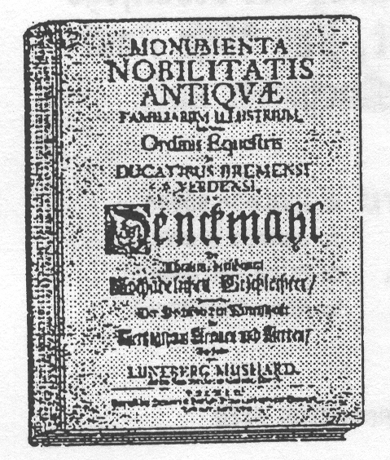
Memorial of the very old, renowned high honorable family, particularly the highly praised knighthood in the Dukedom of Bremen and Verden. . .

“The old noble shield of the Lords von Rönne is parted in the middle by a silver-white streak, dividing two like red-colored fields. Still, in the opening above, covered with a silver and red wreath, is projected above the tournament helmet a green tree with three slim branches protruding on either side; as the authentic illustration shows.
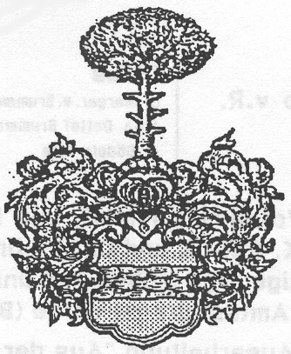

About it, I make the following explanation:
Vir justus cescit liqvidas vehir arbor ad undas,
Spiritus ut sacri codicis auctor ait.
Hanc li justiam servabir porro virescet,
Arbor Ronniadum dum vehit Albis aquas.

A holy minded heart reaches to heavenly fountains
And brings, like a tree, fruit at the right time.
That can the green tree of Rönnen here display,
So long as a branch yet shows the fruit of holiness.

What is related to the first information of this old group of Bremen knights, I could not find something new; however, they, long ago, under the highly praised knighthood of this land were well known and famous. Before then, Archbishop Johannes Rode came to rule. Here, then, also in the well known Mushard chronicle, the named archbishops were counted under the old Kehdingerish royal family line. f.m. 36.

Year 1450 lived Diederich von Rönne, and had received the judgeship in the parish Osten from the Archbishop Gerhardo to feudal tenure. Vid. MSV Archi-Eiscopi Johann Roden.
Year 1500 Diederich, Claus, and Erich von Rönne are living. I d. MSC. 1c.
Year 1572 three of these families are in the muster roll of the Bremen knighthood, are seated with names; namely Claus, Cordt and Berthold von Rönne.
Year 1643 , on July 3rd, Lord Asmus von Rönne, who was endowed at Oetzen, married Mariam von Wersabe, honorable daughter of Lord Wulff=Hinrich of Wersabe from Karlsbruch, with whom he begat 4 sons: i.e. Lords Johan, Wulff-Hinrich, Asimus and Luder von Rönne, and likely a daughter with names Magdalena Elizabeth.
Not a little, was this family line in Denmark extended by Lords Claus von Rönne, kingly Danish captain, and his honorable wife Anna Sophia von Mulheim, daughter of Baltlhasar and lady Magdalena von Wolframsdorf, leaving behind several heirs.”
In the handwritten “Family Bremen Genealogy” (Bremen State Archives), the chronicler Herman Post listed old residing archbishoprics Bremen and Verden. Yet, with the obvious imperfections for the times, which, indeed, the Bremen Knighthood chronicler Luneberg Mushard in 1708 claims for himself, are these Post sketches not unconditionally correct. So Herman Post, for posterity, wrote down:

1. Erick 1500 Burchard-Ilse von Soden
Eler 1423 Derick 1450 Bode—Johann Drewes
Timme v Rönne Direk Gerd Margar.-Erich v Handeln
Wed Ilse Paten Luder-Anna Standenen
Timme Claus 1490
Jacob
Bishop at Roskilde in Denmark 1536

- Otto’s children
Claus Claus Otto were also named
Otto v Rönne Margar, von Hedwig Gerdes Clara von deviating by
Brummer filia filia Otto Gerdes Sangerhause Mushard (It. Claus!)
Detlef Brummer und Magaretha Claus somewhat
And Godele Alfs von Göben Anna-Otto Segeman

The forenames Timme and Elder appear in usage not again! Erick, Dirick and Claus, we find in the “Vorder Register of 1500 and earlier”. This has to us “and earlier” so importantly concealed. First, around 1520, had the princely offices at Vorder (Bremenvorder) taken over the managing work of the jurisdiction.
A composition “From the History of the family von Rönne”, which, in January 1932, appeared in the journal “Low German Homeland” by Gerhard Gerdts, was based likewise on the unfortunately, inadequate Post and Marshard presentations.
In the Vorder Register of 1500 and earlier, in the chapter “Co deme Acker (farm) is also mentioned, in 1475 as land-owner, the name “Otten van deme Runne”.

Desse nabeschrewenen buwen nu to tidt be buwhouse tom Acker de buwhouse horen tho den gennen de hir na volgen:

“OTTO van RUNNE hesst hir ene Rotswere de horet tho”,

The armor bearer Otto von Runne, in 1475 with his wife Mette and son Johann lived in Altendorf.

The above named Knight Gerd von Rönne, married Ilse Platen, was in 1560 a nobleman, in 1572 a knight and still in 1573 titled Lord Judge. He was a son of Otto von Rönne out of the forementioned two family trees (later Denmark lineage) and not the son, but a brother of the older Claus. Father Otto von Rönne would after 1500 be born at Altendorf in the parish Osten and married a Gödele from Söden of a neighbor.

The chronicled data before 1560, as a result, before church books, must be guided, founded upon registrations on taxes and customs rolls, treasure contributions and head numbering, documents from building and land sales, court records (complaints, arraignments and commoner, etc).

Certainly will failure slip in under me too, but today’s material is voluminous and, through this “work up”, is easier to survey! The next chronicler will for sure yet do better. But we come back to the Knights and Armor Bearers!!
In the 13TH to 17TH century, How did one become a Knight?

Service at the courts of the feudal lords often began as a page, armor bearer, nobleman and squire. A year long education and armament techniques were prerequisite to the bestowal of knighthood (sword people) by the elders.

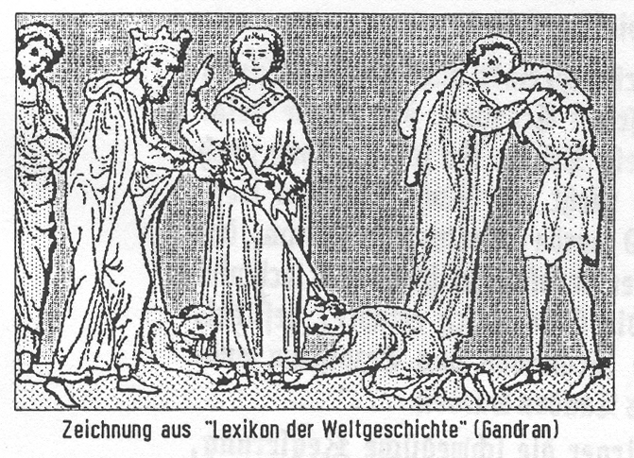
Then followed the raising up of the armor bearer with impressive ceremonies, to which, the church had given its consecration. The armor bearer had spent the night before with prayers: which was the weapon watch. The next day, the candidate, laid clothed in a brown traditional cassock, made confession and took Holy Communion. Then he bathed, put on white garments, laid down and began ceremonial visitations.

After that, he put on the knight’s uniform, the chain-meshed shirt and the cowling, kneeled down—and pledged that he would spare neither his life or his fortunes in order to defend Religion, Widows, Orphans and suppressed people. After this oath, he is equipped with valuable spurs, sword and valor-sash. This sash, he hung around his neck, when he went to church.

After the mass, the priest took the sword, blessed it and gave it back to the one becoming a knight, who now places it before the feudal lord, who sat in the middle of his entourage. Now the candidate knelt and says his second oath toward the assembled knights, he was given the title of Knight with two or three strokes of a flat sword on the shoulder; and, was so “in the name of God, the holy Michael and the holy Georg” become a knight.

Then the new knight took ownership of his helmet, shield and lance; mounted his horse in order to immediately present his new station.

However, a knight who became guilty “of betrayal, renouncing his faith or other’s faith, capital and heinous crimes” would be impaled on a mast up- side- down in full armor.

This knighthood vanished from the scene with the emergence of firearms. The quiet courage of foot soldiers triumphed over the boisterous remonstrations of the last knight.

After that, was the title “Knight” still bestowed, but only as an honorary title indicating a certain order; i. e. also, as a few members of the Rönne family were able to list in their personal papers, as the Knights of Russian St. Andreas Order, the Polish White Eagle Order and the Wladimir Order.

In the “Bremen Knight Register” of 1645, in which “Steed Service Fees” were recorded according to the horses of the nobility, are mentioned four squires von Rönne from the Osten parish; and, so…the Judge Knight Johann had 2 horses; Captains Gertt, Barthold and Otto, each with 1 horse.
Richard A. Rusch, in 1985, wrote in his “Chronicle of Parish Osten”:

“The office of the first judge in the parish was invested, in 1450, to an old established family line “von Rönne” by the archbishop and inherited itself in succession to the oldest son. This important family, had led the story of the parish for almost 200 years.

During the 30 Year War, during the lower Saxony involvement, the parish Osten was also affected with suffering. With the invasion by Tilly troops of Stade, Judge Hinrich von Rönne lost his life. Then his sons, yet minors, the enemy occupation permitted no peace and the parish remained without a judge. In the year 1629, Johann von Rönne, who belonged to a line of the old family, was called to be judge; he held the parish until the end of the great war, which yet involved several invasions into the Osten Marsh. In 1648, Johann von Rönne had to resign his office, as the Swedes had definitely occupied the archbishopric and were also in the Saxon lands.

In the year 1649, and once more in 1659, the Osten people petitioned the Swedish government to again install “Gerd von Rönne”, son of Hinrich who was as a judge in 1627 killed. Still the government denied this; and preferred to vest the judgeship with officials of their own choosing.

Captain Gerd von Rönne, married in the year 1641, and was chosen as “Ober-Teich-Grafen” (supervisor count of the dikes) in the Osten parish.

The deposed Judge Johann von Rönne, at the urging of his parishioners, after hesitation, placed himself, as judge, at the disposal of the Danish occupiers in 1657, during the Second Swedish-Danish War. It lasted only for a short time, for the Swedes retook the area and Johann von Rönne had to flee to Glückstadt. The family property was confiscated because he “to the enemy clung” (consorted).

At first, after a few more petitions to the Swedish governor, the Count von Koenigsmarck, as well as also recommendations by the Danish government, Johann von Rönne, in 1662, was permitted to return. The last judge of the Rönne family received his property back, the Altendorf noble house where he had lived before. This was, however, so run down, and, owing to heavy war reparations, that it brought no joy.

“Progenitor of a common branch”

is pointed out, by a few historians, as Detlef vom Rönne (Ballie-Meierhofe). He was a son of Claus von Rönne and Margareta Brummer from Altendorf. The preacher Dessebrock, in 1634, was installed at a dairy farm. (See Acta F105, Nr. 48, Stade). A Christopher von Rönne, yet in 1637, owned a court “Aushausen estate”, with several parts as church land.

Detlef’s son, Diederich von Rönne became “pastorate Kaethner) at Osten with 18 acres of owned land. This son Detlef von Rönne lived until 1676 and had still at the war’s end (1648) in Oberhüll, a farm with lots of arable land, to where Diederich’s widow, Detlef’s mother moved in 1657. This Oberhüllen family farm, later, went to the family Hottendorf.

